# Assignments of

Inertial Navigation

《惯性导航》作业1 (A)

|  |  |
| --- | --- |
| My Chinese Name | 尉前进 |
| My Student ID. | 1170400423 |

Spring 2020

**Assignment 1(A): Aircraft Displaying on the Earth**

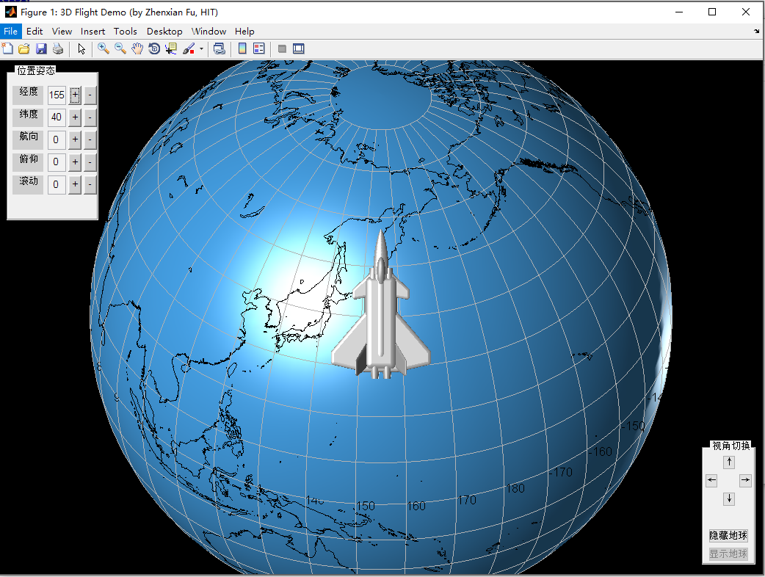

You are given a set of MATLAB programs to display an aircraft near the surface of the Earth, as shown in figure above, which is drawn by running the program main.m.

Initially the aircraft is hidden at the center of the Earth. Then, if you click any of the “+” or “-” buttons, the longitude, latitude, heading, pitching, or rolling angles shown in the boxes (all in degree) will increase or decrease by 5 degrees, and the aircraft are expected to be accordingly displayed both at a proper position on the Earth and with a proper attitude.

The original 3D model of the aircraft is stored in the matrix **vtx0**,, whose each row contains the coordinates of one of its many vertices, defined in the body frame of the aircraft. The Earth frame is chosen as coinciding with the default frame of Matlab graphic system. The Earth is drawn as 10 in radius, and the aircraft is drawn as about 5 in full length. The distance from the center of the Earth to the center of the aircraft can be chosen as 13.

Please rewrite the program redraw.m by transforming the matrix **vtx0** into a new matrix **vtx** corresponding to the current position and attitude of the aircraft, instead of keeping **vtx** the same as **vtx**0. That is, in the program redraw.m, please replace the command line **vtx=vtx0** with your own codes for re-calculating **vtx**.

Before you re-write the program **redraw.m**, the aircraft will be always drawn at the center of the Earth, invisible to you unless you remove the surface of the Earth by clicking “隐藏地球” butten.

Please include the re-written code in your report, as well as your explanation and running results (screen shots).

程序运行结果截图：

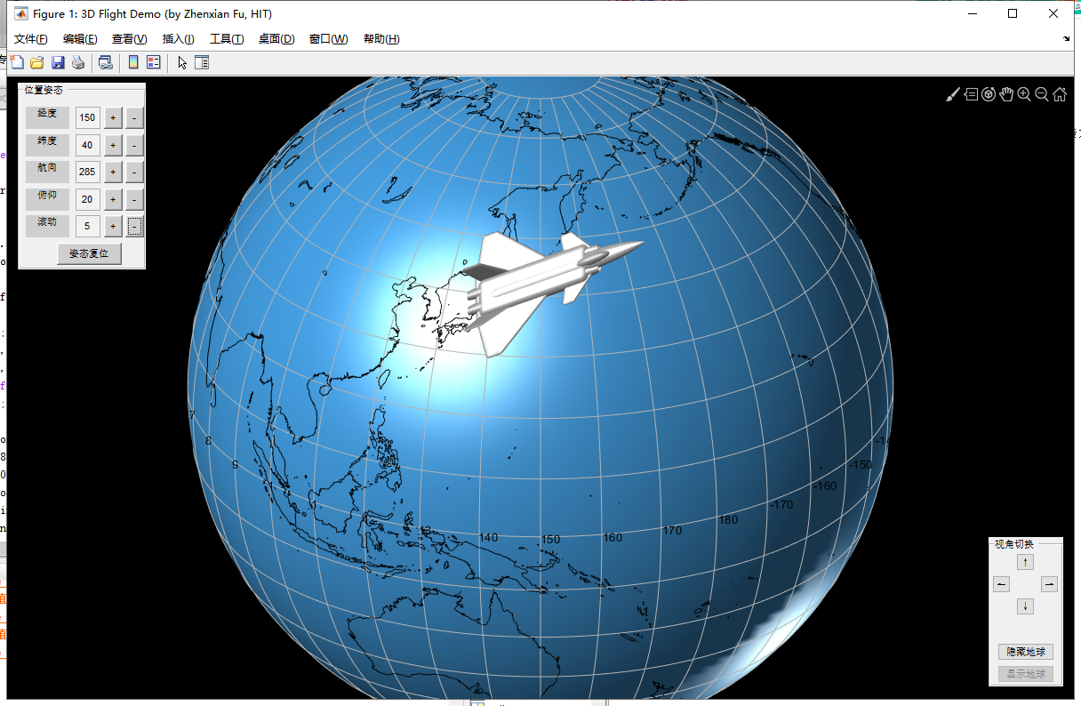

问题解决思路：

1. 从地球坐标系转换到地理坐标系：

从地球坐标系到初始的地理坐标系：



经度发生改变，增大角，则：



纬度发生改变，增大角，则：



得到从地球坐标系到当前地理坐标系的方向余弦矩阵为

再考虑从地理坐标系到当前机体坐标系的方向余弦矩阵：

绕heading轴产生航向角

则对应的从地理坐标系到机体坐标系的方向余弦矩阵为：



绕pitching轴产生俯仰角

则对应的从地理坐标系到机体坐标系的方向余弦矩阵为：



绕rolling轴产生滚动角

则对应的从地理坐标系到机体坐标系的方向余弦矩阵为：



最后得到从地理坐标系到机体坐标系的方向余弦矩阵为

进一步得到从地球坐标系到机体坐标系的方向余弦矩阵为

而本题中是已知机体坐标反解飞机在地球坐标系下的位置信息，因此先求逆在进行矩阵相乘，

由于vtx0是5710*3的矩阵，对它先求转置再左乘方向余弦矩阵的逆，便可得到飞行器在地球坐标系下的实际位置，在为了保证接口的一致性对其取转置，得到vtx。

再进一步，根据坐标平移关系，把飞行器移到地球表面得到最终的vtx。